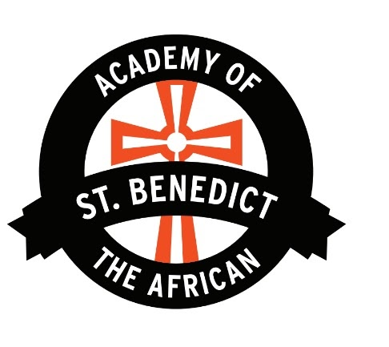
^{KINDERGARTEN​}
SCHOOL SUPPLY LIST 2023-2024 SCHOOL YEAR
Academy of St. Benedict the African
PLEASE send your child’s supplies by the first week of school. You may be asked to replenish these throughout the school year. Thank you for your support as we work to ensure your child is ready for learning on the first day of school. ☺
Required the FIRST DAY of school
• FULL SIZE BOOK BAG
o MANDATORY - ​NO wheels ​NO Lights
o ​LABELED WITH YOUR CHILD’S NAME
o IT MUST BE BROUGHT TO SCHOOL EVERY DAY
SUPPLY LIST (FOR FALL & AGAIN IN JANUARY)
NOTE: Each Student needs to bring a box of masks (at least 100)!
- 4 PUFFS Large Boxes Kleenex
- 6 - 8 Rolls Paper Towels
- 3 packs of Baby Wipes
- 4 Large Containers Clorox wipes
- 2 cans Lysol spray
- 4 boxes Ziploc Bags ​gallon size
- ​4 boxes Ziploc Bags quart size
- 2 Family sized or Refill size Hand Sanitizer – we use it everyday (with PUMP ONLY)
- 2 Large Containers Liquid Hand Soap – (with PUMP ONLY)
- 2 Boxes of gloves (large latex free)
- 4 packs of crayons - Crayola
- 2 packs of washable markers - Crayola
- 2 packs of Coloring Pencils
- 2 packs Dry Erase Markers
- 2 packs pencil - Ticonderoga
- 1 pack of blunt cut scissors
- 2 packs Index Cards
- 1 pack Eraser
- 1 Personal Water Bottle
- 3 packs of glue stick
- 1 box of Bandaid
- 2 pocket folders (blue/red)
- 1 Plastic Spacemaker School Box 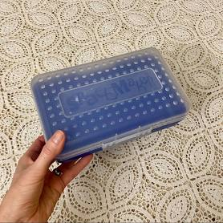
- 2 Composition Notebook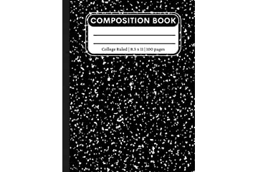
- 1 Headphone 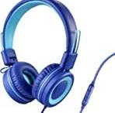
- 2 pk playdoh
- 1 Ream of Copy Paper
- 1 pack of Post-It
- 1 pack Colored construction paper
REMINDER: Please no Light-up bags or shoes. This is disruptive to the class. Thank you for your cooperation!
Thank you for getting the school year off to a great start!

